**Step 1. Create a Repository**

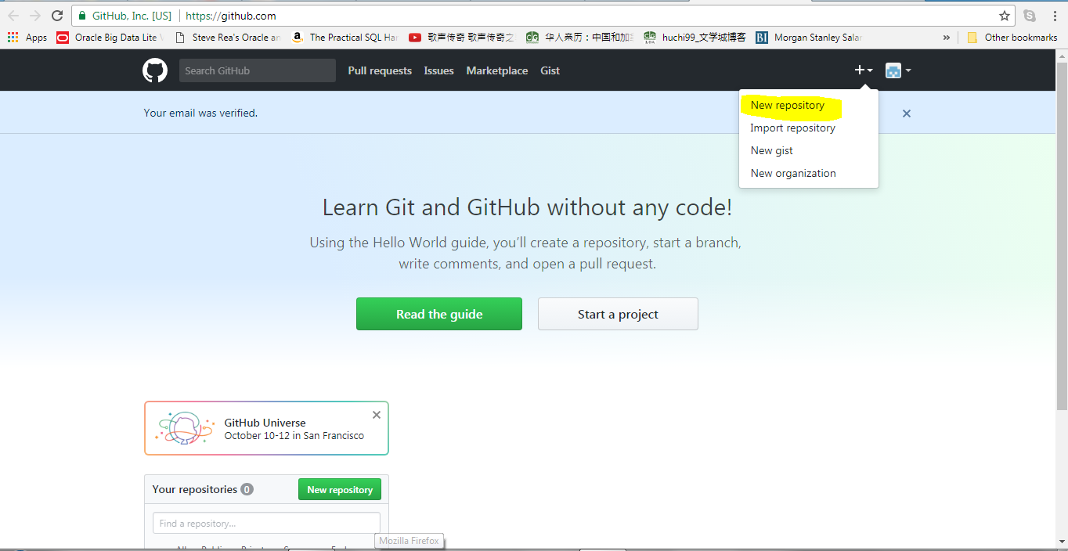

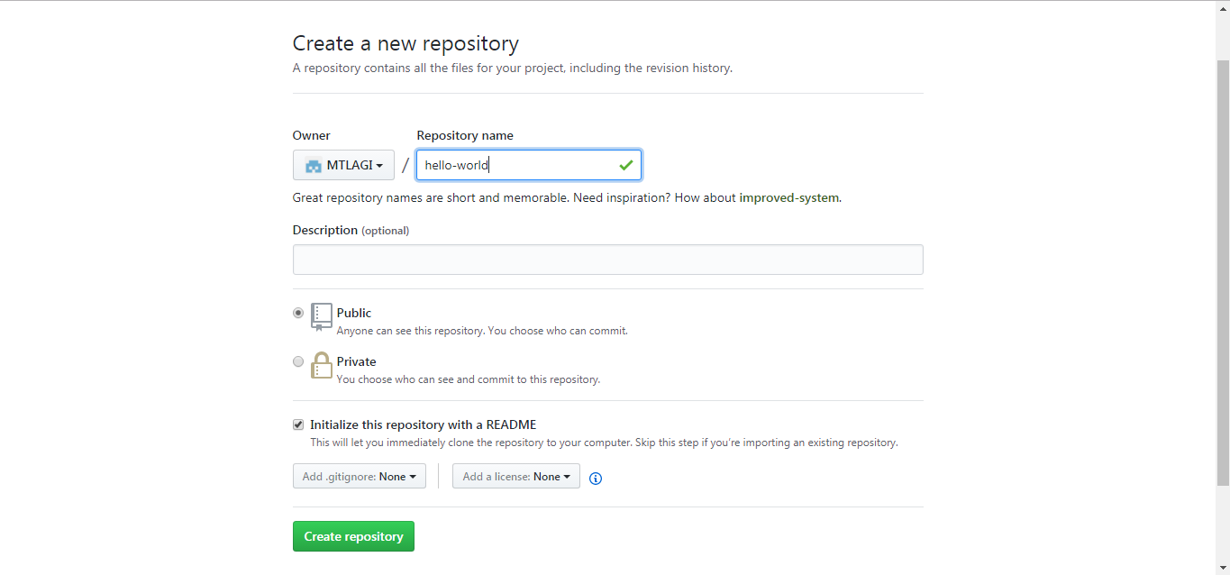

## Step 2. Create a Branch

## 

## 

## Step 3. Make and commit changes

## 

## 

## 

## 

## 

## Step 4. Open a Pull Request

## 

## 

## 

## 

## Step 5. Merge your Pull Request

## 

## 

## 

### Celebrate!

By completing this tutorial, you’ve learned to create a project and make a pull request on GitHub! :tada: :octocat: :zap:

Here’s what you accomplished in this tutorial:

* Created an open source repository
* Started and managed a new branch
* Changed a file and committed those changes to GitHub
* Opened and merged a Pull Request